TREATMENT RESPONSE OF CHRONIC MYELOGENIC LEUKEMIA
IN DR. SOETOMO HOSPITAL

Ugroseno
Hematology and Medical Oncology Division
Department of Internal Medicine
Airlangga University School of Medicine
Dr Soetomo Teaching Hospital, Surabaya

ABSTRACT

Chronic myelogenic leukemia is the most frequent hematology malignancies in adult. In the US, the frequency of CML is about 15% of all hematological malignancies. The incidence was 1-2 : 100.000, with male and female 1.3 : 1, and it increases associated with age 45-55 year. In Internal Medicine Department, Airlangga University School of Medicine, Dr. Soertomo Hospital, Surabaya, CML is the most frequent hematological malignancy after malignant lymphoma. The diagnosis was established by clinical festures such as organomegaly, leukocytosis and bone marrow aspiration. CML treatment includes supportive therapy, chemoteraphy, and stem cell transplantation. The cheaper and frequently used chemotheraphy are busulfan and hydroxyurea, but the response is not satisfying. In CML patient with positive Philadelphia chromosome, treatment with imatinib gives response rate about 90-95%. The purpose of this study was to find out the response of hyrea, busulfan and imatinib therapy on CML. Sample of this study was the patient in Medical Oncology and Hematology Outpatient Clinic of Dr. Soetomo Hospital, from January 1, 2004, to December, 31, 2006. Along this time there were 58 patients with CML. Twenty eight patients were females and the rests were male. The response of patient with myeleran showed that three patients had complete remission. Among those receiving hydroxyurea 6,6 % showed partial remision, and 79.9% patients showed complete remission treatment by imatinib.

Keywords: hematology malignancies, chronic myelogenic leukemia, hyrea, busulfan, imatinib, Dr Soetomo Hospital

Correspondence: Ugroseno, Hematology and Medical Oncology Division, Department of Internal Medicine
Airlangga University School of Medicine, Dr Soetomo Teaching Hospital, Jl Prof Dr Moestopo 6-8,
Surabaya, Indonesia, phone 62-31-5501626

INTRODUCTION

Chronic Myelogenic Leukemia is the most frequent hematological malignancies in adults. In the US, the frequency of CML is about 15% of all hematological malignancies. The incidence is 1-2 : 100.000, with male and female = 1.3 : 1, and it increases associated with age, with median age 45 – 55 year. No data of CML available in Indonesia, but at the Department of Internal Medicine Airlangga University School of Medicine, Dr. Soetomo Hospital, Surabaya, CML is the most frequent hematological malignancy after malignant lymphoma. The diagnosis established by clinical features such as organomegaly, leukocytosis, and bone marrow aspiration. CML treatment includes supportive therapy, chemotherapy, and stem cell transplantation. The cheaper chemotherapy and often used are busulfan and hydroxyurea, but the response is not satisfying. In CML patients with positive Philadelphia chromosome, treatment with Imatinib gives response rate about 90-95%. The purpose of this study was to find out the response of hydrea, busulfan, and imatinib therapy on CML
MATERIALS AND METHODS

Sample of this study is the CML patient treated in Medical Oncology and Hematology Outpatient Clinic of Dr. Soetomo Hospital, Surabaya, from January 1, 2004 to December 31, 2006.

RESULTS

From January 1st 2004 until December 31st 2006, there were 58 patients with CML. Twenty eight patients were females, and the rests were male. General characteristics of those patients is presented in table 1.

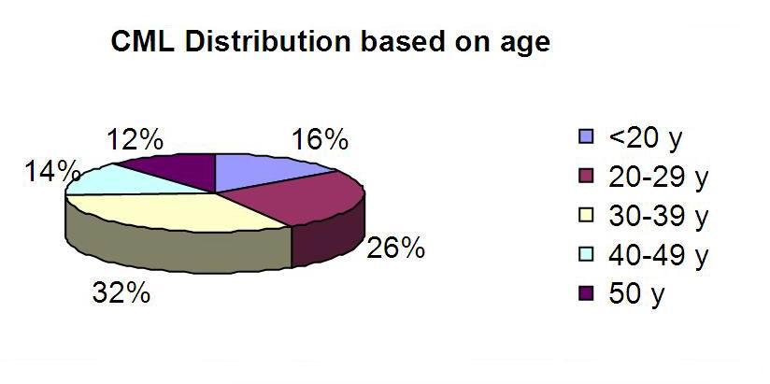
Figure 1. CML distribution based on age.
Table 1. General characteristics of CML patients

- Sex | Frequency
- male : | 30 patients
- female : | 28 patients
- Age
- < 20 y.o. : | 9 patients (16 %)
- 20 - <30 y.o. : | 15 patients (26 %)
- 30 - <40 y.o. : | 19 patients (32 %)
- 40 - <50 y.o. : | 8 patients (14 %)
- ≥ 50 y.o. : | 7 patients (12 %)
3. Modalities of treatment:
- Busulfan : | 26 patients (45%)
- Hydrea : | 18 patients (31%)
- Glivec : | 11 patients (19%)
- untreated | 3 patients (5%

Among 58 CML, 26 patients (45%) were treated by Busulfan, 18 patients (311%) are treated by Hydrea, 11 patients (19%) are treated by Glyvec, and 3 patients (5%) are untreated. The diagnosis is established by peripheral blood smear in 34 patients (52%), cytogenetic in 12 patients (19%).

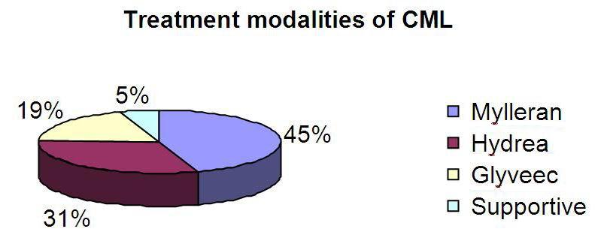

Figure 2. Treatment modalities of CML

Response of treatment is divided into Complete Remission, Partial Remission, Stationary disease, and Progressive Disease. Complete Remission (CR) is defined if the leucocytes < 100.000, thrombocytes < 450.000, myelocytes and metamyelocytes < 5%, no blast or pro-myelocytes and no involvement in extra medulla. Complete Remission is defined cytogenetically if there are no Philadelphia chromosomes in bone marrow. Partial Remission is defined hematologically if leucocytes 20.000-50.000 and cytogenetically if Philadelphia chromosomes 1-35%. Progressive disease is defined if there is acceleration phase or blastic crisis. In 26 patients treated by Myleran, we found 3 patients (12%) showed complete response, 18 patients (68%) with partial response, 3 patients (12%) with stationary disease, and 2 patients (8%) showed progressive disease.

From 18 patients treated by Hydrea, 2 patients (11%) gained complete response, 12 patients (67%) showed partial response, and 4 patients showed stationary disease. Eleven patients treated by Glyvec, 7 patients (79.9%) showed complete response, and 4 patients died (Acute Leukemic transformation).

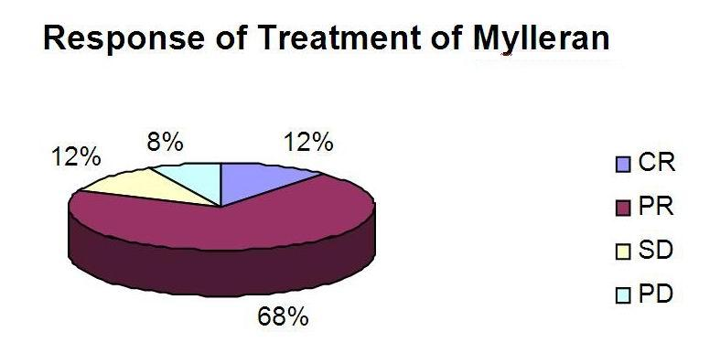
Figure 3. Response of treatment of Mylleran

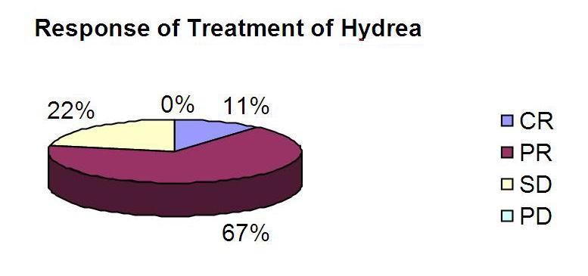
Figure 4. Response of treatment of Hydrea

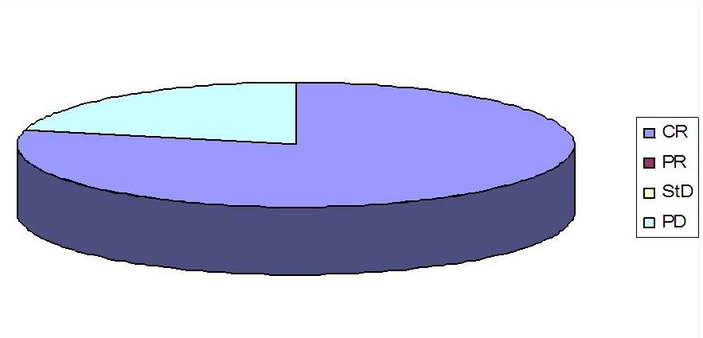

Figure 5. Response of treatment of Glivec

DISCUSSION

CML is hematological malignancies which is one of myeloproliferative disorders. More than 50% of the patients are asymptomatic and are diagnosed by routine blood examination. Generally, they come with complain of fatigue, weight loss, abdominal discomfort, bleeding, night sweating, purpura, and splenomegaly. It is frequently found at age 50-60. Laboratory examination reveals leukocytosis, anemia, and trombocytosis. In this study, most of the patients were 30-40 year old and came with splenomegaly and fatigue. The goal of CML treatment is to reduce leucemic cell proliferation in bone marrow. Variation of treatment depends on natural history or clinical phase of CML. There are three phases of CML: chronic phase, acceleration phase, and blastic crisis. In many developed countries, 85% of CML patients are in chronic phase, acceleration phase and blastic crisis are only 5-10% of all CML patients. In our study, most of the patients were in chronic phase (79%) and only 25 patients were in blastic crisis. In chronic phase, the goal of treatment is to achieve normal leukocyte concentration. Chronic phase is a more responsive to alkylating chemotherapy and interferon. In acceleration phase and blastic crisis, the goal of treatment is to kill cells with ABL-BCR gene in order to turn back to chronic phase. In blastic crisis, the treatment used high dose chemotherapy and be followed by bone marrow transplantation.

In our study, 26 patients (45%) received myleran, 18 patients (31%) received Hydrea, 11 patients (19%) received Imatinib (Glyvec), and 3 patients (5%) were untreated. The types of chemotherapy were chosen based on some considerations including age, leucocyte count, clinical staging, and Philadelphia chromosome. After chemotherapy, we determined response of treatment hematologically, cytologically, and molecular. Hematological response was based on complete blood examination. Cytogenetic responses were based on blood or bone marrow examination with FISH method. Molecular respose was determined by PCR.

Busulfan is an alkylating agent available in Dr. Soetomo Hospital, and often be given to CML patients in chronic patients. It was first introduced in 1950, taken per oral, and inexpensive, but has severe side effect such as prolog myelosuppresion in 10% of the patients, idiosyncratic pulmonary reactions (busulfan lung), bone marrow fibrosis, endocardial fibrosis, and sometimes mimics Addison disease.

Busulfan was taken orally 0.1 mg/kg/day, and commonly decreases leucocytes count and minimizes spleen size in 4-6 weeks. The dose should be reduced 50% if leucocytes count decreases 50% from initial value. Maintenance dose was taken 2-4 mg/day to maintain leukocytes count 10.000-20.000. Busulfan should be stopped if leukocytes count attains 10.000/U.I n our study, patients treated with Busulfan showed partial response to therapy (14,8%).

Hydroxyurea was firstly used for CML therapy in 1972. It has quick action on controlling leukocytes. Generally, hydroxyurea is the first therapy taken to decrease leukocytes count. If it is taken 1-6 gram/day (40 mg/kg/day) orally, it will increase hematological parameter in 2-6 weeks. Dose should be reduced to 1-2 gram if leukocytes count attains 20.000 u/L. Hydrea is well-tolerated by the body and has little side effects (nausea, vomiting, diarrhea, mucosal ulcers). Hydroxyurea can attain complete remission hematologically in 50-80% patients. Meanwhile, there is little data showing remission cytogenetically. Hydroxyurea is better than Busulfan, proved by randomized trial on CML patients with chronic phase showing survival median (56 months treated by Hydrea, and 44 months treated by Busulfan). In our study, group of patients treated by Hydroxyurea showed partial response as much as 6.6%.

Imatinib mexylate is a new drug pursuing tyrosine kinase activities, and is very useful for old patients, IFN-α resistant patients, or CML with Philadelphia chromosome. Philadelphia chromosome occurs because of ABL gene translocation in long-arm of chromosome 9 to BCR gene in long arm of chromosome 22. Imatinib shows hematological response > 95%, in response of cytogenic 76%. Initial dose taken in chronic phase is 400 mg/day and can be added until 600-800 mg/day, until cytogenetic response is gained. According to Sawyers, CML patients treated by Glyvec and showing resistance can be treated by Dasatinib. But early treatment by Dasatinib combined with imatinib can prevent gene mutation leading to both drugs resistance. In our study, there were 11 patients (79.9%) among 14 patients treated by Glyvec 400 mg/day (following GIP AP program) who could attain complete remission. Three patients died because they were transformed to acute leukemia. Transformation to acute leukemia usually occurs in CML acceleration phase and generally in myeloblastic or myelomonocytic type. The price of these drugs is the main problem of Imatinib/dasatinib use in most of CML patients in Indonesia.

CONCLUSION

CML is a hematological malignancy which is frequently occurs. CML is diagnosed clinically by leukocytosis, peripheral blood smear, and hepatosplenomegaly. Drugs used for treatment of CML nowadays are Hydrea, Busulfan, and Imatinib. Among 26 patient treated by Myleran, only 3 patients (12%) could achieve complete remission, while patients treated by hydroxyurea only 6.6% patients showed partial response to therapy, and 79.9% patients treated by Imatinib showed complete response to therapy.
REFERENCES

Druker, BJ, Guilhot, F, O’Brien, SG 2006, ‘Five-year follow-up of patients receiving imatinib for chronic myeloid leukemia’, N Engl J of Med, vol. 355, pp. 2408-2417.
Hoagland, HC 1995, ‘Myeloproliferative diseases’, in JJ Mazza (ed), Manual of Clinical Hematology, 2nd edn, pp. 204-209.
Faderl, S, Talpaz, M, Estrov, Z, Kantarjian, HM, 1999, ’Chronic myelogenous leukemia: Biology and therapy’, Annals of Internal Medicine, vol. 131, pp. 207-219.

Williams J, Lichtman, MA, Beutler, E, Kipps, TJ 2003, ‘The chronic myelogenous leukemia’, in Manual of Hematology, 6th edn, . J Williams, MA Lichtman, E Beutler, TJ Kipps, pp. 249-259.

